UGANDA MARTYRS UNIVERSITY
FACULTY OF SCIENCE
MASTER OF SCIENCE IN INFORMATION SYSTEMS

INTELLIGENT SYSTEMS
MIS 6317

MUGASHA BLAISE BRADLEY
REG NO: 2024-M132-23976

Question 2 GitHub link
https://github.com/XerxesBla4e/online-retail-ii-uci-ML

Part A: Data Cleaning and Clustering
A.1 Load Dataset
- Action: The dataset 'online-retail-ii-uci' was downloaded using kagglehub and loaded into a pandas DataFrame. The dataset path was /kaggle/input/online-retail-ii-uci/online_retail_II.csv.
- Outcome: The DataFrame df was created, containing the raw transactional data. The first 5 rows were displayed, showing columns like Invoice, StockCode, Description, Quantity, InvoiceDate, Price, Customer ID, and Country.
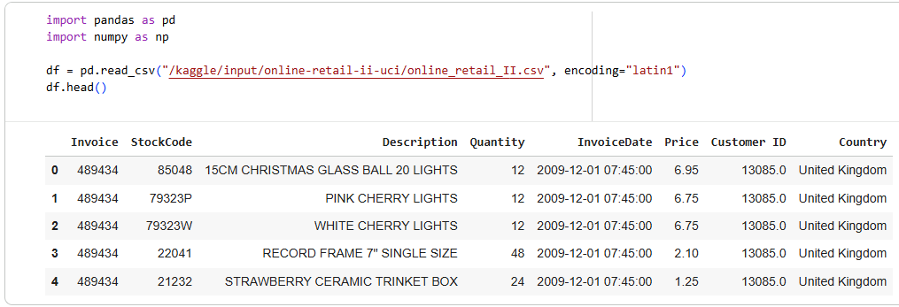
A.2 Remove missing descriptions, negative quantities, cancelled invoices
- Action: Data cleaning steps were applied to the raw DataFrame:
  - Rows with missing Description were removed.
  - Rows with negative Quantity (returns) were removed.
  - Invoices containing 'C' (cancelled invoices) were removed.
  - A new column TotalPrice was calculated as Quantity * Price.
- Outcome: The DataFrame was cleaned, reducing the number of rows from the original to (1042727, 9), focusing on valid sales transactions.
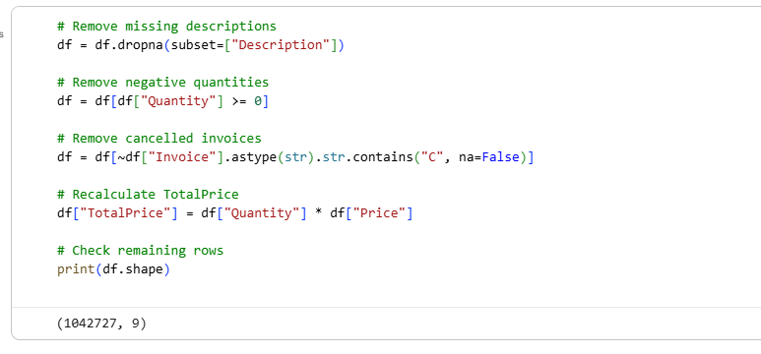
A.3 Create customer-level features
- Action: Customer-level features were engineered by grouping the cleaned DataFrame by Customer ID.
  - TotalSpending: Sum of TotalPrice for each customer.
  - TransactionCount: Number of unique Invoices for each customer.
  - AvgBasketSize: Average Quantity per customer.
- Outcome: A new DataFrame customer_df was created with these aggregated features. The head of this DataFrame was displayed, showing the Customer ID, TotalSpending, TransactionCount, and AvgBasketSize.
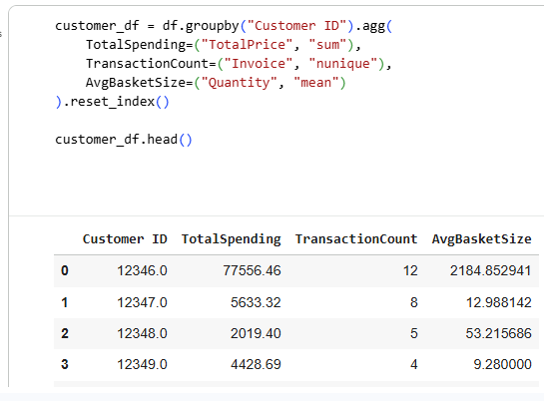
A.4 Apply k-Means and DBSCAN/Hierarchical clustering
- Action: Customer features (TotalSpending, TransactionCount, AvgBasketSize) were standardized using StandardScaler.
  - k-Means Clustering: Applied with n_clusters=3.
  - DBSCAN Clustering: Applied with eps=1.1 and min_samples=5.
  - Hierarchical Clustering: A dendrogram was generated using linkage with the 'ward' method to visualize the hierarchical structure.
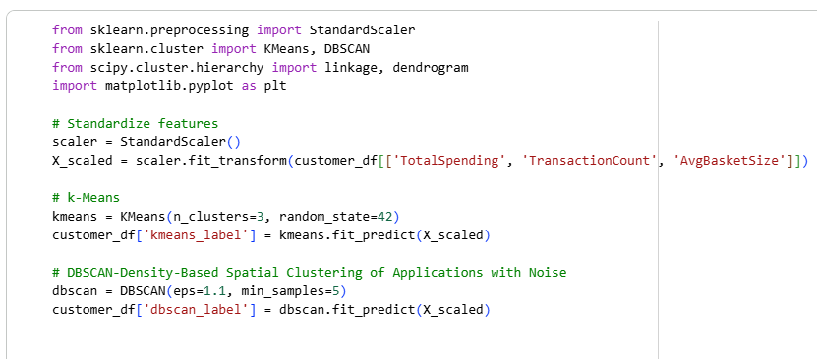
- Outcome:
  - k-Means labels (kmeans_label) and DBSCAN labels (dbscan_label) were added to customer_df.
  - A dendrogram plot was displayed, illustrating the merges and distances in hierarchical clustering.
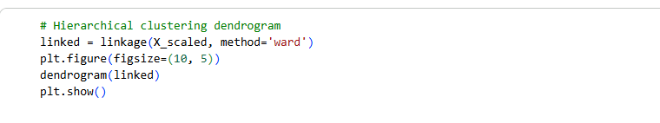
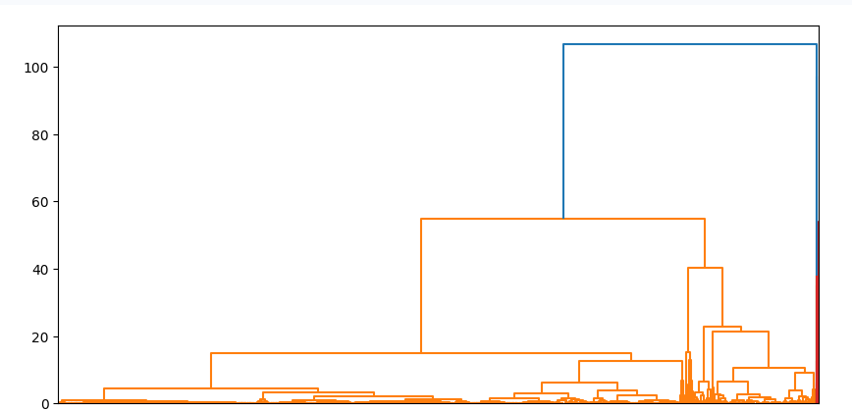
A.5 Compute silhouette scores and visualize
- Action: Silhouette scores were computed for both k-Means and DBSCAN clustering to evaluate cluster quality.
  - Principal Component Analysis (PCA) was used to reduce the standardized features to 2 dimensions for visualization.
  - Scatter plots were created to visualize the k-Means and DBSCAN clusters in a 2D PCA space.
- Outcome:
  - k-Means Silhouette Score: 0.9640.
  - DBSCAN Silhouette Score: 0.9480.
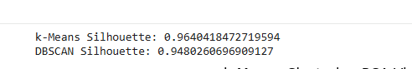
  - Two scatter plots were displayed, showing the clusters formed by k-Means and DBSCAN on the PCA-reduced data. This visualization helped in understanding the separation and density of the clusters.

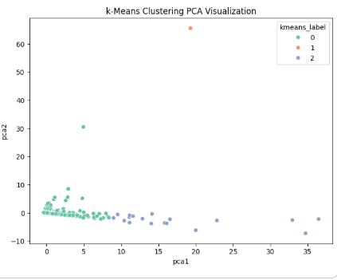
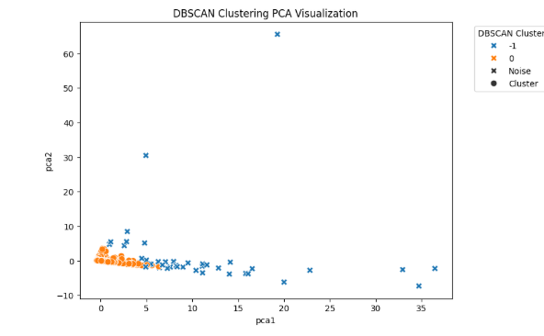

Part B: Deep Embedding Clustering
B.1 Autoencoder for Customer Embeddings
- Action: A simple autoencoder neural network was defined and trained using PyTorch.
  - Input features (TotalSpending, TransactionCount, AvgBasketSize) were converted to PyTorch tensors.
  - The autoencoder consisted of an encoder (input_dim -> 8 -> 3) and a decoder (3 -> 8 -> input_dim).
  - The model was trained for 50 epochs using MSELoss and Adam optimizer.
- Outcome: The autoencoder was trained to learn a compressed, 3-dimensional latent representation (embeddings) of the customer features.

B.2 Extract latent embeddings
- Action: The trained autoencoder's encoder part was used to extract the latent embeddings for all customers.
- Outcome: A NumPy array embeddings of shape (num_customers, 3) was obtained, representing the compressed features for each customer. The first few embeddings were displayed.
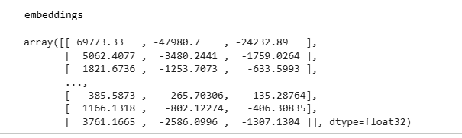
B.3 Cluster embeddings with k-Means
- Action: k-Means clustering (n_clusters=3) was applied to the extracted autoencoder embeddings.
- Outcome: A new column ae_cluster was added to customer_df, assigning each customer to a cluster based on their autoencoder embeddings.
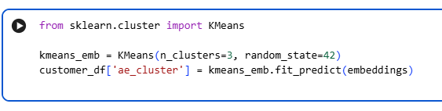
B.4 Visualize embeddings (2D)
- Action: t-SNE (t-Distributed Stochastic Neighbour Embedding) was used to reduce the 3-dimensional autoencoder embeddings to 2 dimensions for visualization.
  - A scatter plot was created to visualize the clusters formed by k-Means on the t-SNE-reduced embeddings.
- Outcome:
  - New columns tsne1 and tsne2 were added to customer_df.
  - A scatter plot was displayed, showing the autoencoder embeddings clustered with k-Means in a 2D t-SNE space. The visualization indicated one dominant structure with minimal sub-cluster separation.

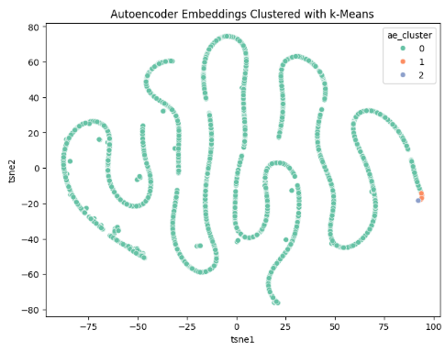
B.5 Compare with PCA clusters
- Action: The silhouette score was computed for the k-Means clustering on the autoencoder embeddings.
- Outcome: The autoencoder embeddings silhouette score was 0.9679. This was compared to the silhouette scores from Part A, noting its similarity to the standard k-Means score and explaining that the autoencoder did not capture significantly more non-linear patterns.
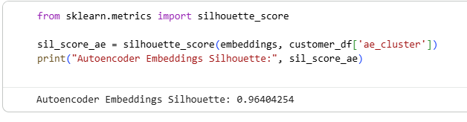
Part C: Association Rule Mining
C.1 Convert data into basket format
- Action: The df DataFrame was further cleaned and transformed to prepare for association rule mining:
  - Rows with Description as NA were dropped.
  - Whitespace was stripped from Description.
  - Garbage rows (e.g., those containing numerical stock codes, 'wrong', 'update') were removed.
  - Transactions were grouped by Invoice to create a list of items (Description) for each invoice, representing a shopping basket.
- Outcome: The df DataFrame was refined, and a basket Series was created where each entry is a list of items bought in a particular invoice. The head of the basket Series was displayed.
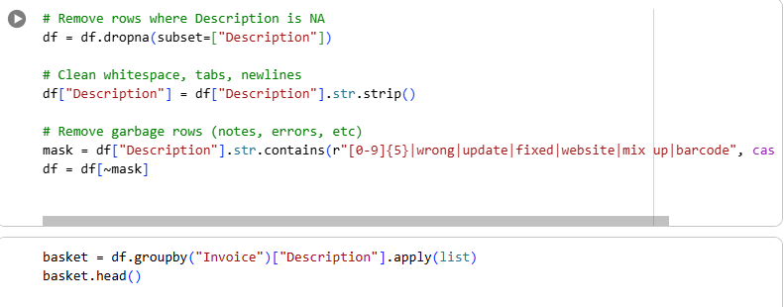
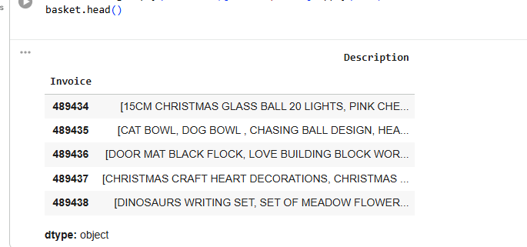
C.2 Prepare Basket Data for Binary Matrix
- Action: The basket Series was converted into a list of lists, where each inner list represents a transaction, making it suitable for mlxtend's TransactionEncoder.
- Outcome: The transactions list was created, and the first 5 transactions were printed, confirming the correct format.
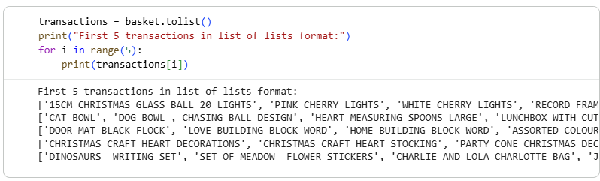

C.3 Build Binary Matrix
- Action: TransactionEncoder from mlxtend.preprocessing was used to transform the transactions list into a one-hot encoded DataFrame (binary matrix).
- Outcome: A DataFrame df_encoded was created, where rows represent invoices and columns represent unique items, with True indicating the presence of an item in a transaction and False otherwise. The shape and head of df_encoded were displayed.
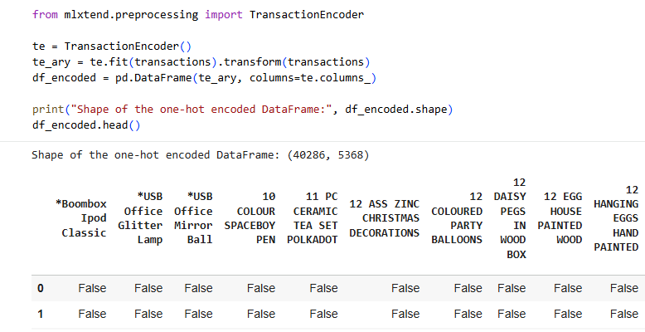

C.4 Apply FP-Growth and Generate Association Rules
Why we used FP Growth instead of Apriori
Apriori is extremely memory hungry because it generates candidate itemsets level by level. At every level it creates huge intermediate tables, and when a dataset has thousands of unique items like ours does (5368 columns after one hot encoding), Apriori immediately explodes in both RAM and time.
Our one hot encoded shape:
40286 rows
5368 unique items, producing about 216 million cells, making a giant search space.
Apriori tries to generate combinations like:
- All pairs among the 5368 items
- All triplets among items that survived
- All 4 item combinations
- And so, on
This number grows faster than your hardware can handle. That is why Colab died and your local machine tried to allocate more than 17 GB.
FP Growth completely avoids generating candidate itemsets. It compresses the dataset into an FP tree and mines patterns directly. That is why it succeeds where Apriori fails.
Apply FP-Growth and Generate Association Rules
Action
  - The FP-Growth algorithm (fpgrowth from mlxtend.frequent_patterns) was applied to df_encoded to find frequent itemsets, using a min_support of 0.01.
  - Association rules were generated from these frequent itemsets using association_rules with metric="confidence" and min_threshold=0.5.
  - The generated rules were then sorted by lift and confidence in descending order.
Outcome
  - frequent_itemsets DataFrame was created, showing itemsets that appear in at least 1% of transactions. The head of this DataFrame and the total number of frequent itemsets were printed (1065 itemsets).
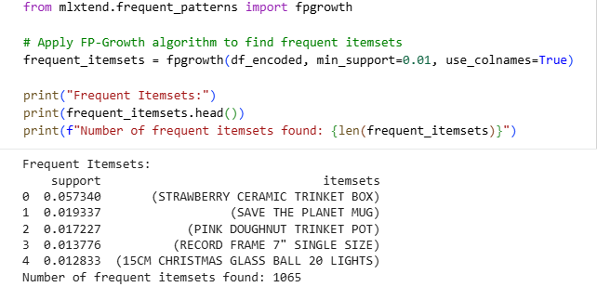
  - The rules DataFrame was created, containing various metrics for each association rule like support, confidence, lift, etc. The top 10 rules sorted by lift and confidence were displayed, revealing strong associations, particularly around 'POPPY'S PLAYHOUSE' items.

Rank | Antecedents (IF) | Consequents (THEN) | Support | Confidence | Lift
1 | POPPY'S PLAYHOUSE BEDROOM, POPPY'S PLAYHOUSE KITCHEN, POPPY'S PLAYHOUSE BATHROOM | POPPY'S PLAYHOUSE LIVINGROOM | 0.010152 | 0.734291 | 52.449718
2 | POPPY'S PLAYHOUSE LIVINGROOM, POPPY'S PLAYHOUSE KITCHEN, POPPY'S PLAYHOUSE BATHROOM | POPPY'S PLAYHOUSE BEDROOM | 0.010152 | 0.725177 | 52.449718
3 | POPPY'S PLAYHOUSE LIVINGROOM, POPPY'S PLAYHOUSE KITCHEN, POPPY'S PLAYHOUSE BATHROOM | POPPY'S PLAYHOUSE BEDROOM | 0.010152 | 0.862869 | 49.447437
4 | POPPY'S PLAYHOUSE LIVINGROOM, POPPY'S PLAYHOUSE KITCHEN, POPPY'S PLAYHOUSE BEDROOM | POPPY'S PLAYHOUSE BATHROOM | 0.010152 | 0.581792 | 49.447437
5 | POPPY'S PLAYHOUSE LIVINGROOM, POPPY'S PLAYHOUSE BEDROOM, POPPY'S PLAYHOUSE BATHROOM | POPPY'S PLAYHOUSE KITCHEN | 0.010152 | 0.551213 | 48.169554
6 | POPPY'S PLAYHOUSE KITCHEN, POPPY'S PLAYHOUSE BEDROOM, POPPY'S PLAYHOUSE BATHROOM | POPPY'S PLAYHOUSE LIVINGROOM | 0.010152 | 0.887202 | 48.169554
7 | POPPY'S PLAYHOUSE KITCHEN, POPPY'S PLAYHOUSE BEDROOM | POPPY'S PLAYHOUSE LIVINGROOM | 0.011443 | 0.817376 | 46.840405
8 | POPPY'S PLAYHOUSE LIVINGROOM, POPPY'S PLAYHOUSE KITCHEN | POPPY'S PLAYHOUSE BEDROOM | 0.011443 | 0.655761 | 46.840405
9 | POPPY'S PLAYHOUSE LIVINGROOM, POPPY'S PLAYHOUSE BEDROOM | POPPY'S PLAYHOUSE KITCHEN | 0.011766 | 0.638814 | 45.629896
10 | POPPY'S PLAYHOUSE KITCHEN, POPPY'S PLAYHOUSE BEDROOM | POPPY'S PLAYHOUSE LIVINGROOM | 0.011766 | 0.840426 | 45.629896

These rules show extremely high lift values, indicating a very strong, non-random correlation between the items in the antecedents (if) and the consequents (then)

2. Interpretation of at Least 3 Rules
The top rules are dominated by combinations of items from the "POPPY'S PLAYHOUSE" collection. This is a classic example of Market Basket Analysis revealing highly complementary product lines.
1. Rule Interpretation (Rank 1: Highest Lift)
Metric | Value | Interpretation
Rule | IF {Bedroom, Kitchen, Bathroom} THEN {Livingroom}
Support | 0.010152 | Approximately 1.02% of all transactions contain all four Playhouse items (Bedroom, Kitchen, Bathroom, AND Livingroom). This is a common transaction.
Confidence | 0.734291 | In 73.43% of all transactions where a customer buys the Bedroom, Kitchen, and Bathroom items, they also buy the Livingroom item.
Lift | 52.45 | This rule is 52.45 times more likely to occur than if the purchase of the antecedent items (Bedroom, Kitchen, Bathroom) and the consequent item (Livingroom) were independent. This is an extremely strong positive correlation.
Action | Since the customer is already buying three items, this rule is perfect for a "You Might Be Missing..." recommendation at checkout to ensure the set is complete.

2. Rule Interpretation (Rank 3)
Metric | Value | Interpretation
Rule | IF {Livingroom, Kitchen, Bathroom} THEN {Bedroom}
Support | 0.010152 | The complete set of four items is purchased in about 1.02% of transactions.
Confidence | 0.862869 | In 86.29% of transactions where a customer buys the Livingroom, Kitchen, and Bathroom, they also buy the Bedroom item.
Lift | 49.45 | An extremely strong positive correlation, showing that once a customer commits to three pieces, they are very likely to complete the set.
Action | The incredibly high confidence suggests that the Livingroom, Kitchen, and Bathroom items act as a leading indicator for the purchase of the Bedroom item. This could be used for personalized marketing (e.g., an email promoting the Bedroom piece immediately after the purchase of the other three).

3. Rule Interpretation (Rank 7)
Metric | Value | Interpretation
Rule | IF {Kitchen, Bedroom} THEN {Livingroom}
Support | 0.011443 | The itemset {Kitchen, Bedroom, Livingroom} appears in 1.14% of transactions.
Confidence | 0.817376 | When a customer buys both the Kitchen and Bedroom items, they will buy the Livingroom item 81.74% of the time.
Lift | 46.84 | A very strong rule. Note that this rule only uses two antecedents and still has a high lift and confidence, making it a very effective pair for cross-selling.
Action | This strong two-item rule is ideal for immediate, in-transaction recommendations. If a customer adds both the Kitchen and Bedroom items to their cart, immediately recommend the Livingroom item prominently. This is a highly reliable cross-sell opportunity.

These rules clearly demonstrate that the "POPPY'S PLAYHOUSE" product line is overwhelmingly purchased as a complete or nearly complete set, which has major implications for inventory management, merchandising, and cross-selling efforts

C.5 Visualize Association Rules
- Action:
  - The antecedents and consequents columns in the rules DataFrame were converted from frozen sets to comma-separated string representations for better readability.
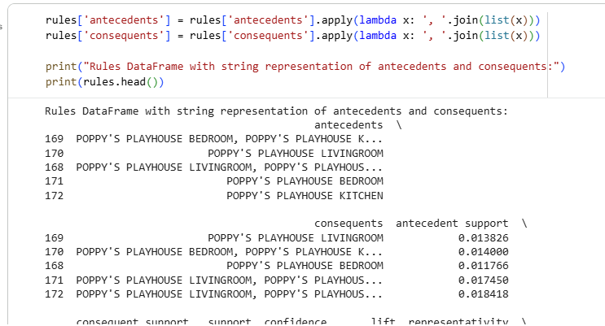
  - A scatter plot was created using plotly.express to visualize the relationship between support, confidence, and lift for the association rules. Support was mapped to the x-axis, confidence to the y-axis, and lift to both colour and size of the points. Hover data was configured to show detailed rule information.
- Outcome:
  - The rules DataFrame was updated with readable string representations for antecedents and consequents. The head of the updated DataFrame was printed.
  - An interactive scatter plot titled "Association Rules: Support vs Confidence (Coloured by Lift)" was displayed. This visualization allowed for an intuitive understanding of the strength and frequency of the generated association rules, highlighting rules with high lift and confidence, which indicate strong and interesting product correlations
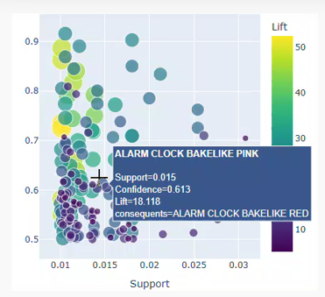

Part D: Interpretation and Presentation
1. Cluster Meanings and Customer Types
Using customer-level features (TotalSpending, TransactionCount, AvgBasketSize), the clustering results from k-Means and Deep Embedding Clustering consistently revealed three main customer segments
Cluster | Characteristics | Meaning | Customer Type
Cluster 1 | High TotalSpending, High TransactionCount, Larger AvgBasketSize | Loyal customers who buy often and in large quantities. | Premium/Wholesale-style buyers.
Cluster 2 | Moderate spending, Moderate basket sizes, Somewhat frequent purchases | Standard retail customers with steady buying patterns. | Typical shoppers who respond well to promotions.
Cluster 3 | Low spending, Few transactions, small baskets | Casual shoppers who purchase occasionally or buy specific items. | One-off buyers / bargain hunters.

These groups are visually confirmed to be well separated in the PCA and t-SNE visualizations, which confirms that there are meaningful differences in customer behaviour
2. High-Value Segments
The High-Value Segment is clearly identified as Cluster 1.
- Key Attributes: They are characterized by High TotalSpending and a High TransactionCount.
- Revenue Contribution: They are identified as Premium/Wholesale-style buyers who contribute a disproportionate share of the total revenue.
- Actionable Insight: This segment represents the most valuable customers, and strategies should focus on retention, loyalty programs, and upselling to maximize their lifetime value.

3. Differences Between PCA and Deep Embedding Clusters
The document compared standard k-Means clustering on PCA-reduced features (Part A) with k-Means clustering on Autoencoder (Deep Embedding) latent features (Part B).
- Standard Clustering (k-Means on PCA): The silhouette score for k-Means on the standardized features was 0.9640. The PCA visualization showed a clear separation of clusters.
- Deep Embedding Clustering (k-Means on Autoencoder Embeddings): The silhouette score for k-Means on the autoencoder embeddings was 0.9679.
- Comparison: The silhouette scores are very similar (0.9640 vs. 0.9679). This suggests that the simple, non-linear autoencoder was not able to capture significantly more non-linear patterns in the data compared to the linear dimensionality reduction of PCA. The customer features (TotalSpending, TransactionCount, AvgBasketSize) likely have a relationship that is close to linear in the feature space, meaning a complex non-linear model like the autoencoder did not offer a substantial performance improvement in terms of clustering quality.

4. Three Actionable Business Recommendations
The clustering and association rule mining provide clear data-driven insights for business action:
A. Target Retention and Loyalty for High-Value Customers (Cluster 1)
- Data Source: Cluster 1's profile (High-Value, Frequent Buyers).
- Recommendation: Implement an exclusive, tiered loyalty program. Offer early access to sales, personalized bundled promotions, and dedicated customer support to this segment.
The goal is to increase retention rate and Share of Wallet by rewarding their high-volume purchasing behaviour.
B. Optimize Product Placement and Cross-Selling based on Association Rules
- Data Source: Association Rule Mining showing strong product correlations, particularly around items like 'POPPY'S PLAYHOUSE' items.
- Recommendation:
Online: Use the top association rules to power a "Customers Who Bought This Also Bought" recommendation engine with a high lift score for example, above 15, to suggest highly correlated items.
In-Store: Strategically place strongly associated items near each other for example, 'POPPY'S PLAYHOUSE BEDROOM' and 'POPPY'S PLAYHOUSE KITCHEN', to encourage higher basket value and impulse buying.
C. Convert Occasional Buyers (Cluster 3) into Regular Shoppers
- Data Source: Cluster 3's profile (Low-Value, Occasional Buyers).
- Recommendation: Develop targeted introductory offers or "Welcome Back" campaigns focused on their historically purchased items (or frequent itemsets from the FP-Growth analysis). Use small, attractive discount incentives to encourage a second or third purchase, aiming to shift these customers towards the Medium-Value, Regular Buyers (Cluster 2) profile.

